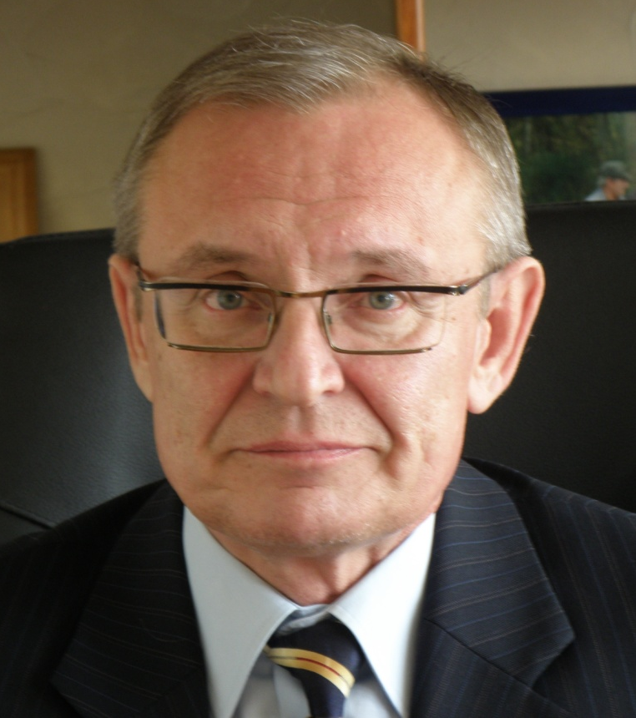
Andrey Glushkov, born in 1956, Doctor of Medical Sciences, Professor, author and co-author of more than 240 publications, including: 150 articles in leading Russian scientific journals and 70 publications in foreign scientific journals, as well as 2 monographs and 6 patents.
He started his scientific career in 1986 as a research scientist at the Institute of Bioorganic Chemistry of the Siberian Branch (SB) of the USSR Academy of Sciences (Novosibirsk), in 1992 – head of the Laboratory of Cancer Immunochemistry at the Presidium of the Krasnoyarsk Scientific Center of the Siberian Branch of the Russian Academy of Sciences (RAS) (Kemerovo), in 1999−2004 – Head of the Department of Cancer Immunology under the Presidium of the Krasnoyarsk Scientific Center of the Siberian Branch RAS. From 2003 to 2009 - Chairman of the Presidium of the Krasnoyarsk Scientific Center of the Siberian Branch of the RAS. In 2004 - founder and Director of the Institute of Human Ecology SB RAS. At present - Director of the Institute of Human Ecology of the Federal Research Center for Coal and Coal Chemistry SB RAS.

- Glushkov is an acknowledged expert in the field of biomedicine and ecology. He developed a scientific concept about the role of immunity in carcinogenesis. He leads a new promising area in cancer immunology - the vaccines discovery against chemical carcinogens for cancer and congenital malformations prevention. Based on these developments, research is currently taken place on the draft state task 0352-2019-0011, as well as on the grant of the Russian Science Foundation 16-15-00034.

Member of the Joint Academic Board of Life Sciences SB RAS and the Siberian Regional Branch of the RAS Scientific Council on Ecology and Emergencies.

